Warren Buffett plowed $5 billion into Bank of America during the debt-ceiling crisis of 2011. Here's a look back at one of the most lucrative deals of his career.
Theron Mohamed
Updated

Jan 14, 2023, 5:53 PM
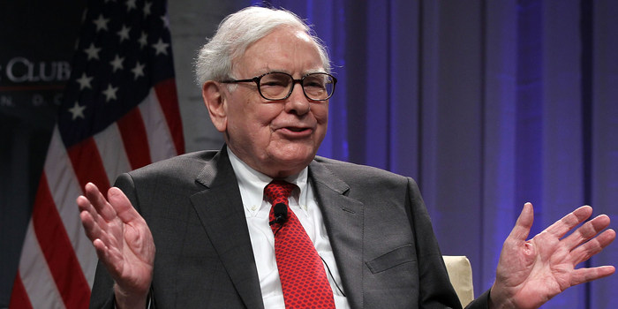
Warren Buffett. Alex Wong / Getty Images
- Warren Buffett plowed $5 billion into Bank of America during the US debt-ceiling crisis in 2011.
- The famed investor and Berkshire Hathaway CEO had the idea to invest while taking a bath.
- Buffett's Berkshire Hathaway counts Bank of America as its number-two holding after Apple.
Sign up for our newsletter to get the inside scoop on what traders are talking about — delivered daily to your inbox.

Email address
By clicking ‘Sign up’, you agree to receive marketing emails from Insider as well as other partner offers and accept our Terms of Service and Privacy Policy.

Warren Buffett struck one of the must lucrative deals of his career when he agreed to inject $5 billion into Bank of America during the US debt-ceiling crisis in 2011.
Here's the story of how the billionaire investor and Berkshire Hathaway CEO shored up confidence in of America's biggest banks and made a fortune in the process.

A bathtub, a call center, and a billion-dollar deal
Buffett was taking a bath in late August 2011, reflecting on his investments in American Express and Geico during difficult periods for both companies, when he had the idea to bet on Bank of America, Fortune reported at the time.
Soon after, the investor picked up the phone and tried to get through to the bank's CEO, Brian Moynihan. He was initially thwarted by a call-center worker.
"Warren asked to speak to me and of course they don't transfer everybody who calls the call centers to the CEO's line," Moynihan told Bloomberg in 2019.
Buffett eventually got through to Moynihan and proposed an investment in his company. Moynihan replied that Bank of America didn't need the capital.
"I know, that's why I'm calling," Buffett responded, adding that accepting his money would provide stability, a stamp of approval, and a cash cushion.
Moynihan agreed, and the pair signed a deal less than 24 hours after speaking for the first time. Buffett's cash landed in Bank of America's account a couple of days later.

Warren gets his warrants
Buffett and Moynihan agreed that Berkshire would invest $5 billion in cash to Bank of America, in return for $5 billion worth of preferred shares, which were redeemable at a 5% premium and paid a 5% annual dividend.
Berkshire also received stock warrants granting it the right to buy 700 million of the bank's common shares at a price of $7.14 per share. The warrants could be exercised at any point over the next decade.
The deal terms echoed Buffett's bailouts of Goldman Sachs and General Electric during the 2008 financial crisis. The investor demanded preferred stock and warrants in those deals too.
Buffett outlined his rationale for betting on Bank of America in his 2011 shareholder letter.
"Some huge mistakes were made by prior management," he said. "Brian Moynihan has made excellent progress in cleaning these up."
The bank chief was "nurturing a huge and attractive underlying business that will endure long after today's problems are forgotten," Buffett continued, adding that Berkshire's warrants "will likely be of great value before they expire."
The investor waited to use the warrants until the annual dividends from 700 million common shares exceeded the $300 million in yearly income that Berkshire was receiving from its preferred stock.
He exercised all of the warrants in August 2017, and covered the $5 billion cost of doing so by giving up virtually all of Berkshire's preferred shares.
The common shares it received were worth over $20 billion at the end of 2017, meaning Berkshire more than tripled its money on paper, even before accounting for the dividends it received.
Berkshire has boosted the position since then to north of 1 billion shares, valued around $35 billion today. Buffett's company is the the bank's biggest shareholder with a roughly 13% stake, while Bank of America is Berkshire's second-largest holding after Apple.
Buffett has been chasing another "eureka" moment ever since.
"I've spent a lot of time in the bathtub since and nothing's come to me," he quipped at Berkshire's annual shareholder meeting in 2017.
"Clearly, I either need a new bathtub or we've got to get to a different kind of market," he added.
Read more: David Rubenstein views Warren Buffett as the ultimate investor. The Carlyle billionaire outlines the 12 traits and habits that are critical to Buffett's success.

